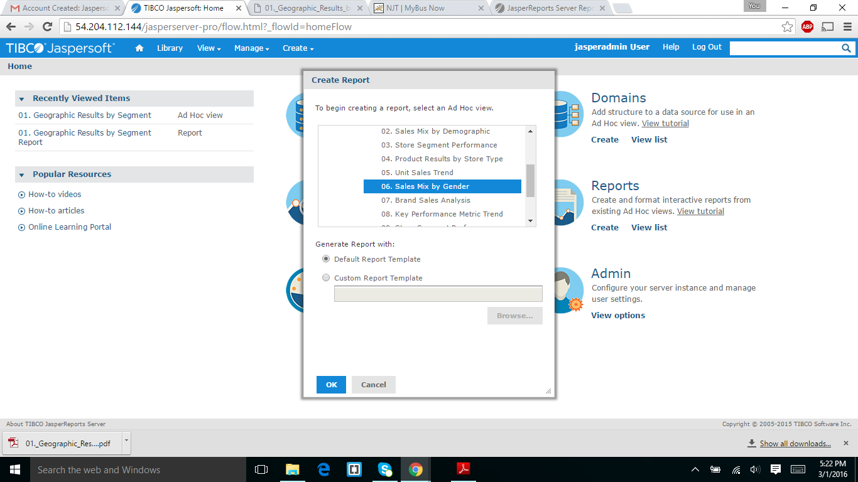

I selected the 06 sales mix by gender as which you that in student id.

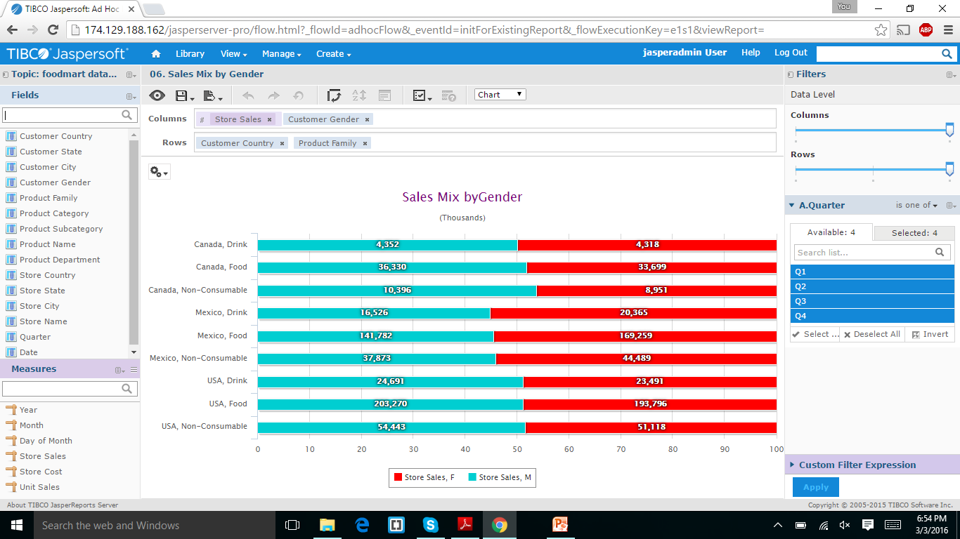

It was displayed the above result which it and I export it into excel file,by pressing the export button.